SOFTWARE PERSONNEL MANAGEMENT SYSTEM(K.GAYATHRI)~192311448

Use Case Diagram:
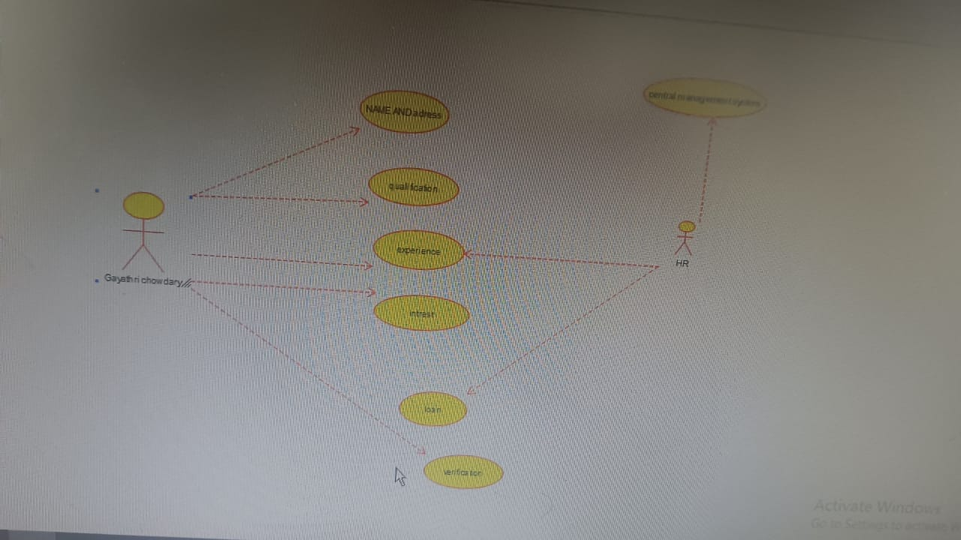
Class Diagram:
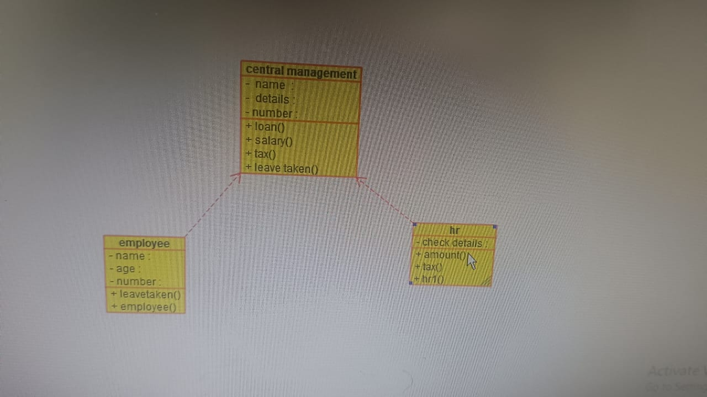
Activity Diagram:
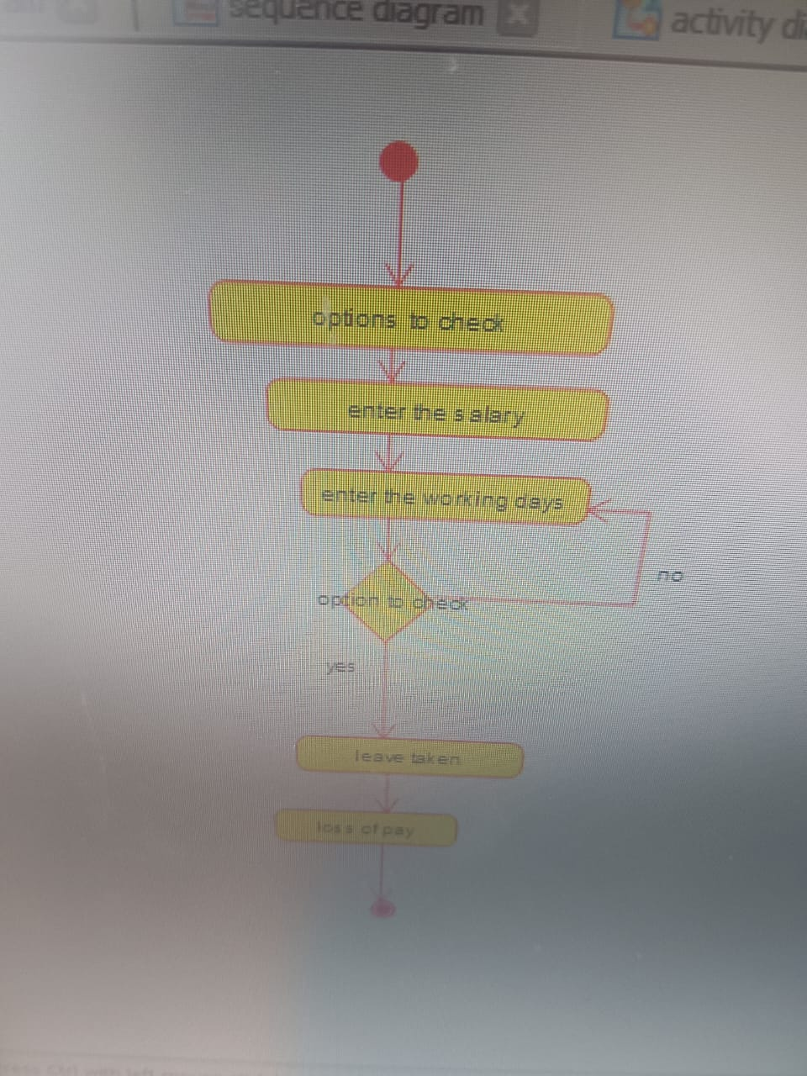

State Diagram:
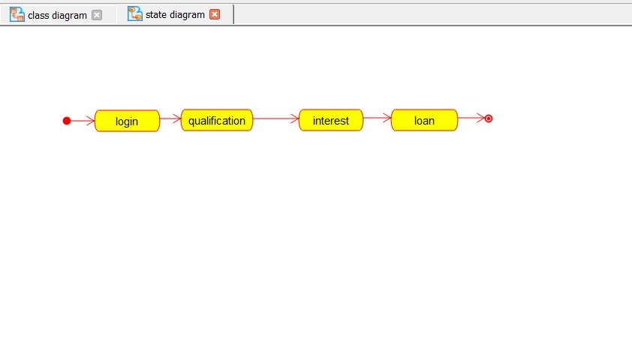

Sequence Diagram:
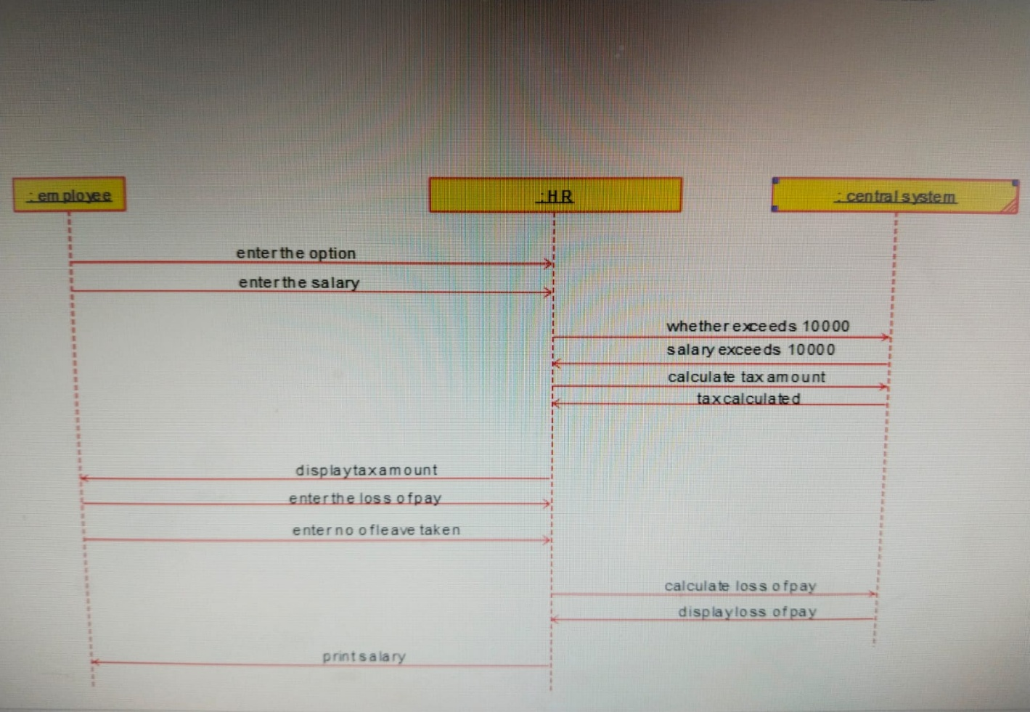

Component Diagram:
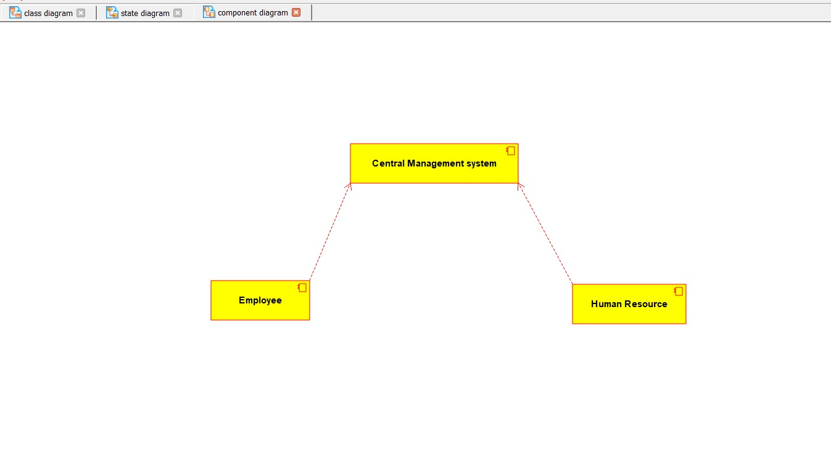

Deployment Diagram:
